# Changing Hair Colour in an Image With Photoshop

In this **photo retouching tutorial**, we are going to look at one method of changing colours, in this example in Photoshop by tinting and colourizing someone’s hair in a photo. The technique we will be learning gives us complete control over what we are doing, with several different ways of fine-tuning the results. Plus we can also go back any time you want and change the hair colour without having to redo all the work. You can use this technique on photos of other people (friends, family etc), or you could use it on a photo of yourself to see how different hair colours would look on you.

The image below is the one to be used for this tutorial:



The original image

For this lesson the hair will be changed brighter a slightly more reddish. You will have complete control over the colour you use with your image, as well as the intensity of the colour. Here’s how when completed:



The final result

At the end of the tutorial, you will see how easy it is to go back and change the colour to something completely different. Let’s get started.

## Step 1: Add a "Hue/Saturation" Adjustment Layer

1. With our image open in Photoshop.
2. Click on the **New Adjustment Layer** icon at the bottom of the Layers palette (the circle split diagonally between black and white):

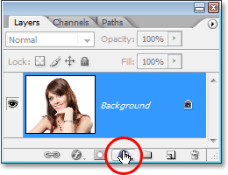

3 Click on the “New Adjustment Layer” icon.

Then select **Hue/Saturation** from the list of adjustment layers that appears:

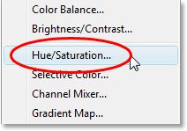

Select a “Hue/Saturation” adjustment layer.

## Step 2: Select the “Colourize” Option

2 When the Hue/Saturation dialog box opens, tick the **Colourize** option in the bottom right corner.

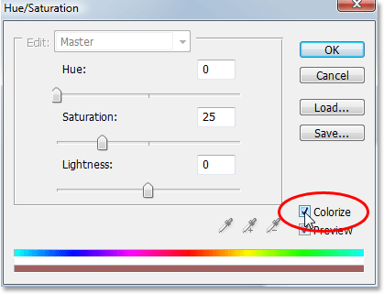

Select the “Colourize” option.

As soon as you select the Colourize option, you’ll see your entire image become colourized with a shade of red.

## Step 3: Select a New Colour for The Hair

1 Drag the **Hue** slider left or right to select the colour you want to use for the person’s hair.

For the moment, you’ll be colourizing the entire image, but we’ll fix that in the next couple of steps. Just ignore the rest of the image for now and focus only on the hair.

Once you’ve found a colour you like, adjust the intensity of the colour by dragging the **Saturation** slider left or right.

Dragging it to the right gives you a more saturated colour, while dragging it to the left reduces the saturation.

Don’t worry about getting the colour and saturation perfect because you can always go back and change it quite easily later. I’m going to set my Hue amount to about 9 and increase the Saturation to around 45 for now:

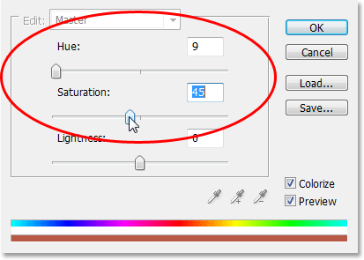

Use the Hue slider to select a new colour for the hair and adjust the intensity of the colour with the Saturation slider.

2 Click OK when you’re done to exit out of the dialog box. The woman’s hair now appears colourized in red, but so is the rest of her:



The entire image is now colourized in red

## Step 4: Fill the Hue/Saturation Layer’s Mask with Black

One of the great things about adjustment layers in Photoshop is that each one automatically comes with its own **layer mask**, in this exercise it will be used to fix the problem we currently have with our entire image being colourized, when all we really want to achieve is for the hair to be colourized.

To start with, let’s completely hide the effects of the Hue/Saturation adjustment layer by filling its layer mask with black.

Since black is our current Background colour and the layer mask is already selected (Photoshop automatically selected the layer mask for us when we added the adjustment layer and set our Foreground and Background colours to white and black, respectively).

All we need to do is use the keyboard shortcut **Ctrl+Backspace** to fill the layer mask with black.

As soon as we do, the colourizing effect disappears from our image and if we look in the Layers palette located on the right hand side of the screen, we can see that the adjustment layer’s thumbnail, which gives us a preview of what the layer mask looks like, is now filled with black:

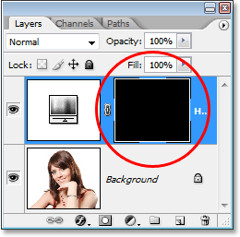

The Layers palette showing the layer mask thumbnail for the Hue/Saturation adjustment layer now filled with black.

## Step 5: Select the Brush Tool

To bring back the colourizing effect and have it applied only to the hair, all we need to do is paint with white on our layer mask over the hair.

Anywhere we paint with white on the layer mask will reveal the effects of the Hue/Saturation adjustment layer, and anywhere we leave black will keep the effects hidden.

First, we need the **Brush Tool**, so either select it from the Tools palette or press the letter **B** on your keyboard to select it with the shortcut:

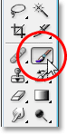

Select Photoshop’s Brush Tool.

We need to paint with white on the layer mask to reveal the colourizing effect on the hair, and Photoshop has already set our Foreground colour to white for us, as we can see in the Foreground and Background colour swatches near the bottom of the Tools palette (the swatch on the left is the Foreground colour and the swatch on the right is the Background colour):

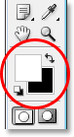

Photoshop’s Tools palette showing white as our Foreground colour and black as our Background colour.

We also already have our layer mask selected, and we can tell that because the layer mask thumbnail in the Layers palette has a white highlight border around it, as shown in the image for Step 4 above, which tells us that the mask is selected.

## Step 6: Paint with White over the Hair

With our Brush Tool selected, the layer mask for the Hue/Saturation adjustment layer selected, and white as our Foreground colour, all we need to do now is paint over the hair.

To quickly change your brush size as you paint, use the **left and right bracket keys** on your keyboard. The left bracket key makes the brush smaller and the right one makes it larger.

You’ll want to use a soft-edged brush, so hold down your **Shift** key and press the **left bracket key** a few times to soften its edges (holding Shift and pressing the right bracket key a few times makes the brush edges harder). Then simply paint over the hair to bring back the colourizing effect:

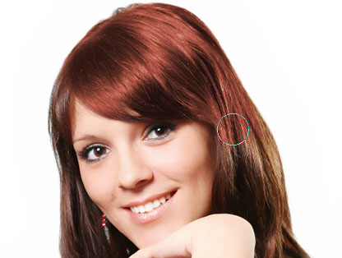

Paint with white over the hair to reveal the colourizing effect from the Hue/Saturation adjustment layer.

For trickier areas where there’s only loose strands of hair, go up to the **Options Bar** at the top of the screen and lower the **Opacity** of the brush down to about **25%** or so:



Lowering the opacity of the brush in the Options Bar.

Then lower the size of your brush so it’s no bigger than the area you’re colourizing and paint over it a couple of times.

This way, the colour won’t be so intense in those areas. You may find it helps to zoom in on those areas as well, and the easiest way to do that is to hold down the **Ctrl** key and the **Spacebar** and drag a selection around the area. Photoshop will then zoom into the area you selected:

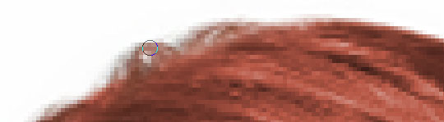

Zoom into the areas of loose strands if needed and paint over them a couple of times with a lower opacity brush.

Press **Ctrl+Alt+0** when you’re done to zoom back out to 100%.

If you make a mistake as you’re painting and accidentally paint over an area you didn’t mean to (happens all the time), simply press **X** to swap your Foreground and Background colours.

Making black your Foreground colour, and paint over the mistake to undo it. Then press **X** again to set your Foreground colour back to white and continue painting until you have all the hair colourized:

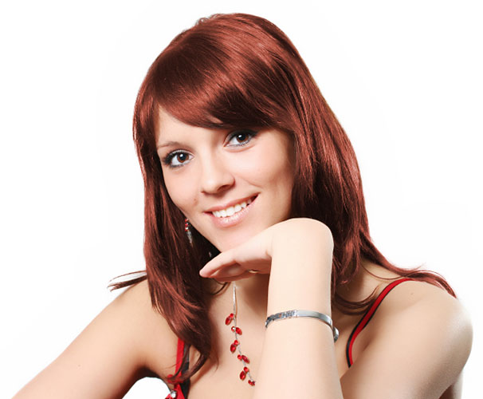

The woman’s hair is now colourized while the rest of the image is not.

We’ll look at how to fine-tune the effect next.

## Step 7: Change the Blend Mode to either “Colour” or “Soft Light”

The hard part is done!

We’ve colourized the hair while leaving the rest of the image untouched thanks to the layer mask that came with the Hue/Saturation adjustment layer.

Now we can fine-tune the effect, and the first way to do that is by changing the **blend mode** of the adjustment layer.

By default, the blend mode is set to “Normal”, and it works fairly well, but let’s change it to something better.

1 Go up to the blend mode options in the top left corner of the Layers palette.

2 click on the down-pointing arrow to the right of the word “Normal”, and select either **Colour** or **Soft Light** from the list:

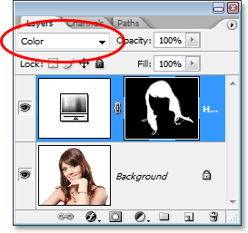

Change the blend mode of the adjustment layer to either “Colour” or “Soft Light”.

The “Colour” blend mode gives us even more of a colourizing effect, since it changes only the colour of an image (when we had the blend mode set to “Normal”, it was affecting not only the colour but also the lightness values of the hair). Here’s my image with the blend mode of the adjustment layer set to "Colour":



The image with the blend mode of the adjustment layer set to “Colour”. Only the colour of the hair is being affected. The lightness values in the hair are not being affected).

The “Soft Light” blend mode gives us a more dramatic colourizing effect because it not only changes the colour of the hair but also boosts the contrast, which I think works even better than the “Colour” blend mode in this case. Here’s my image with the blend mode set to “Soft Light”:



The image with the blend mode of the adjustment layer set to “Soft Light”, giving us a more dramatic effect.

Choose the blend mode that works best with your image.

## Step 8: Lower the Opacity of the Adjustment Layer if Needed

Another way to fine-tune the colourizing effect is by lowering the opacity of the adjustment layer.

If you find the colour is too intense, simply go up to the **Opacity** option in the top right corner of the Layers palette (across from the blend mode option) and lower it until you’re happy with the results.

Here, I’ve lowered the opacity of the adjustment layer to 75 - 50%:

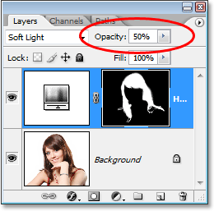

Lower the opacity of the adjustment layer for a more subtle colourizing effect.

This gives me a more subtle colourizing effect:



The image after lowering the opacity of the adjustment layer.

## Step 9: Edit the Hue/Saturation Settings to Change the Hair Colour As Needed

At this point we’re done, but if you need to go back and change the hair colour to something different, simply double-click on the Hue/Saturation adjustment layer’s thumbnail in the Layers palette (the thumbnail on the left, not the layer mask thumbnail on the right):

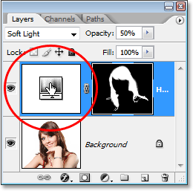

Double-click on the adjustment layer’s thumbnail to edit the Hue/Saturation settings and change the hair colour.

This brings the Hue/Saturation dialog box back up and we can change the hair colour simply by dragging the Hue slider to something different.

We can also re-adjust the saturation of the colour with the Saturation colour. Since this is an adjustment layer, we’re free to make as many changes as we want without worrying about damaging our image.

Mess about a bit, I set my Hue slider to 304 to give her hair more of a pink/purple look:

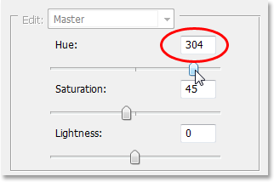

Adjust the Hue slider to change the hair colour again.

I’m also going to set the blend mode of the adjustment layer back to “Colour” and increase the opacity to around 75%:

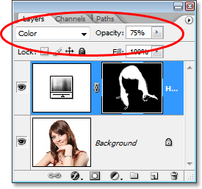

Setting the blend mode back to Colour and raising the opacity to 75%.

And here’s my new result:

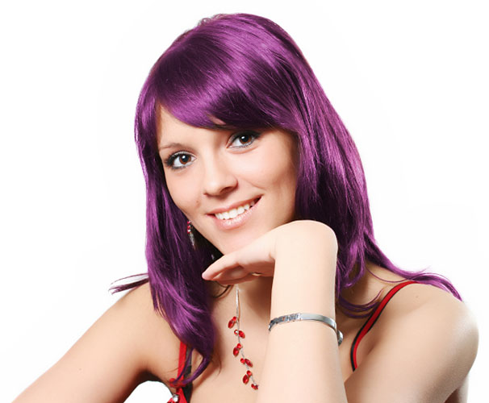

The image after changing the hair colour and saturation, blend mode and opacity value.

And there we have it. That’s how to change someone’s hair colour in Photoshop.This brings the Hue/Saturation dialog box back up and we can change the hair color simply by dragging the Hue slider to something different. We can also re-adjust the saturation of the color with the Saturation color. Since this is an adjustment layer, we’re free to make as many changes as we want without worrying about damaging our image. Just for fun, I’ll set my Hue slider to 304 to give her hair more of a pink/purple look:



Adjust the Hue slider to change the hair color again.

**Changing Hair Color In An Image With Photoshop**

Written by Steve Patterson.   
In this **photo retouching tutorial**, we’re going to look at how simple and easy it is to **change hair color in Photoshop** by tinting and colorizing someone’s hair in a photo. The technique we’ll be learning here gives us complete control over what we’re doing, with several different ways of fine-tuning the results, plus we can also go back any time we want and change the hair color without having to redo all the work! You can use this technique on photos of other people (friends, family, clients), or you can even use it on a photo of yourself to see how different hair colors would look on you!

**[Download our tutorials as print-ready PDFs!](http://www.photoshopessentials.com/print-ready-pdfs/)** Learning Photoshop has never been easier!

Here’s the image I’ll be using for this tutorial:



The original image.

We’re going to be giving her hair a brighter, slightly more reddish color to it in this tutorial, but you have complete control over the color you use with your image, as well as the intensity of the color. Here’s how she’ll look when we’re done:



The final result.

At the end of the tutorial, we’ll see how easy it is to go back and change the color to something completely different. Let’s get started!

**Step 1: Add A "Hue/Saturation" Adjustment Layer**

With our image open in Photoshop, click on the **New Adjustment Layer** icon at the bottom of the Layers palette (the circle split diagonally between black and white):



Click on the “New Adjustment Layer” icon.

Then select **Hue/Saturation** from the list of adjustment layers that appears:



Select a “Hue/Saturation” adjustment layer.

**Step 2: Select The “Colorize” Option**

When the Hue/Saturation dialog box opens, select the **Colorize** option in the bottom right corner by clicking inside its checkbox:



Select the “Colorize” option.

As soon as you select the Colorize option, you’ll see your entire image become colorized with a shade of red.

**Step 3: Select A New Color For The Hair**

Drag the **Hue** slider left or right to select the color you want to use for the person’s hair. For the moment, you’ll be colorizing the entire image, but we’ll fix that in the next couple of steps. Just ignore the rest of the image for now and focus only on the hair. Once you’ve found a color you like, adjust the intensity of the color by dragging the **Saturation** slider left or right. Dragging it to the right gives you a more saturated color, while dragging it to the left reduces the saturation.

Don’t worry about getting the color and saturation perfect because you can always go back and change it quite easily later. I’m going to set my Hue amount to about 9 and increase the Saturation to around 45 for now:



Use the Hue slider to select a new color for the hair and adjust the intensity of the color with the Saturation slider.

Click OK when you’re done to exit out of the dialog box. The woman’s hair now appears colorized in red, but so is the rest of her:



The entire image is now colorized in red.

**Step 4: Fill The Hue/Saturation Layer’s Mask With Black**

One of the great things about adjustment layers in Photoshop is that each one automatically comes with its own **layer mask**, and we’re going to use it to fix the problem we currently have with our entire image being colorized when all we really want is for the hair to be colorized.

To start with, let’s completely hide the effects of the Hue/Saturation adjustment layer by filling its layer mask with black. Since black is our current Background color and the layer mask is already selected (Photoshop automatically selected the layer mask for us when we added the adjustment layer and set our Foreground and Background colors to white and black, respectively), all we need to do is use the keyboard shortcut **Ctrl+Backspace** (Win) / **Command+Delete** (Mac) to fill the layer mask with black.

As soon as we do, the colorizing effect disappears from our image and if we look in the Layers palette, we can see that the adjustment layer’s thumbnail, which gives us a preview of what the layer mask looks like, is now filled with black:



The Layers palette showing the layer mask thumbnail for the Hue/Saturation adjustment layer now filled with black.

**Step 5: Select The Brush Tool**

To bring back the colorizing effect and have it applied only to the hair, all we need to do is paint with white on our layer mask over the hair. Anywhere we paint with white on the layer mask will reveal the effects of the Hue/Saturation adjustment layer, and anywhere we leave black will keep the effects hidden. First, we need the **Brush Tool**, so either select it from the Tools palette or press the letter **B** on your keyboard to select it with the shortcut:



Select Photoshop’s Brush Tool.

We need to paint with white on the layer mask to reveal the colorizing effect on the hair, and Photoshop has already set our Foreground color to white for us, as we can see in the Foreground and Background color swatches near the bottom of the Tools palette (the swatch on the left is the Foreground color and the swatch on the right is the Background color):



Photoshop’s Tools palette showing white as our Foreground color and black as our Background color.

We also already have our layer mask selected, and we can tell that because the layer mask thumbnail in the Layers palette has a white highlight border around it, as shown in the image for Step 4 above, which tells us that the mask is selected.

**Step 6: Paint With White Over The Hair**

With our Brush Tool selected, the layer mask for the Hue/Saturation adjustment layer selected, and white as our Foreground color, all we need to do now is paint over the hair. To quickly change your brush size as you paint, use the **left and right bracket keys** on your keyboard. The left bracket key makes the brush smaller and the right one makes it larger. You’ll want to use a soft-edged brush, so hold down your **Shift** key and press the **left bracket key** a few times to soften its edges (holding Shift and pressing the right bracket key a few times makes the brush edges harder). Then simply paint over the hair to bring back the colorizing effect:



Paint with white over the hair to reveal the colorizing effect from the Hue/Saturation adjustment layer.

For trickier areas where there’s only loose strands of hair, go up to the **Options Bar** at the top of the screen and lower the **Opacity** of the brush down to about **25%** or so:

Adobe Photoshop Tutorial - Digital Photo Editing image

Lowering the opacity of the brush in the Options Bar.

Then lower the size of your brush so it’s no bigger than the area you’re colorizing and paint over it a couple of times. This way, the color won’t be so intense in those areas. You may find it helps to zoom in on those areas as well, and the easiest way to do that is to hold down the **Ctrl** (Win) / **Command** (Mac) key and the **Spacebar** and drag a selection around the area. Photoshop will then zoom into the area you selected:



Zoom into the areas of loose strands if needed and paint over them a couple of times with a lower opacity brush.

Press **Ctrl+Alt+0** (Win) / **Command+Option+0** (Mac) when you’re done to zoom back out to 100%.

If you make a mistake as you’re painting and accidentally paint over an area you didn’t mean to (happens all the time), simply press **X** to swap your Foreground and Background colors, making black your Foreground color, and paint over the mistake to undo it. Then press **X** again to set your Foreground color back to white and continue painting until you have all the hair colorized:



The woman’s hair is now colorized while the rest of the image is not.

We’ll look at how to fine-tune the effect next!

**Step 7: Change The Blend Mode To Either “Color” Or “Soft Light”**

The hard part is done! We’ve colorized the hair while leaving the rest of the image untouched thanks to the layer mask that came with the Hue/Saturation adjustment layer. Now we can fine-tune the effect, and the first way to do that is by changing the **blend mode** of the adjustment layer. By default, the blend mode is set to “Normal”, and it works fairly well, but let’s change it to something better. Go up to the blend mode options in the top left corner of the Layers palette, click on the down-pointing arrow to the right of the word “Normal”, and select either **Color** or **Soft Light** from the list:



Change the blend mode of the adjustment layer to either “Color” or “Soft Light”.

The “Color” blend mode gives us even more of a colorizing effect, since it changes *only* the color of an image (when we had the blend mode set to “Normal”, it was affecting not only the color but also the lightness values of the hair). Here’s my image with the blend mode of the adjustment layer set to "Color":



The image with the blend mode of the adjustment layer set to “Color”. Only the color of the hair is being affected. The lightness values in the hair are not being affected).

The “Soft Light” blend mode gives us a more dramatic colorizing effect because it not only changes the color of the hair but also boosts the contrast, which I think works even better than the “Color” blend mode in this case. Here’s my image with the blend mode set to “Soft Light”:



The image with the blend mode of the adjustment layer set to “Soft Light”, giving us a more dramatic effect.

Choose the blend mode that works best with your image.

**Step 8: Lower The Opacity Of The Adjustment Layer If Needed**

Another way to fine-tune the colorizing effect is by lowering the opacity of the adjustment layer. If you find the color is too intense, simply go up to the **Opacity** option in the top right corner of the Layers palette (across from the blend mode option) and lower it until you’re happy with the results. Here, I’ve lowered the opacity of the adjustment layer to 50%:



Lower the opacity of the adjustment layer for a more subtle colorizing effect.

This gives me a more subtle colorizing effect:



The image after lowering the opacity of the adjustment layer.

**Step 9: Edit The Hue/Saturation Settings To Change The Hair Color As Needed**

At this point we’re done, but if you need to go back and change the hair color to something different, simply double-click on the Hue/Saturation adjustment layer’s thumbnail in the Layers palette (the thumbnail on the left, not the layer mask thumbnail on the right):



Double-click on the adjustment layer’s thumbnail to edit the Hue/Saturation settings and change the hair color.

This brings the Hue/Saturation dialog box back up and we can change the hair color simply by dragging the Hue slider to something different. We can also re-adjust the saturation of the color with the Saturation color. Since this is an adjustment layer, we’re free to make as many changes as we want without worrying about damaging our image. Just for fun, I’ll set my Hue slider to 304 to give her hair more of a pink/purple look:



Adjust the Hue slider to change the hair color again.

I’m also going to set the blend mode of the adjustment layer back to “Color” and increase the opacity to around 75%:



Setting the blend mode back to Color and raising the opacity to 75%.

And here’s my new result:



The image afterChanging the hair color and saturation, blend mode and opacity value.

And there we have it! That’s how easy it is to change someone’s hair color in Photoshop!